**Design Thinking**

**F.Y.B.Tech**

**2017-18 Sem 2**

**Mind Benders**

1. **Shubham Katte**
2. **Swastika Gosavi**
3. **Shivani Turkar**
4. **Krushna Garkal**

**Smart Parking System**

The problem identified was the lack of an efficient parking system. This was a problem for the faculty members, the students of this campus and the visitors who come to this campus. We spoke to some users of the parking lot and even had some users fill survey forms. Some of the users asked for a system that was less time consuming, better infrastructure in the lot, installation of security cameras in the lot, enforcing strict rules to ensure that no vehicles get damaged and some more.

We began by making a solid algorithm for our program. The algorithm would run in such a way that all the slots would be checked if they are occupied and then the nearest empty slot would be displayed. Upon deciding to use Python as the language for our program we wrote the syntax and executed the program, which gave the desired output. For the hardware part of the project, we decided to use IR sensors in every parking slot and they would be connected via connectors to an Arduino Uno board. To make the system better, we added GUI to our program, added the sensors so that the user wouldn’t have to wait or even select any options at the entrance.

By introducing our product into the user’s life, we’ll save a lot of the user’s time daily. By introducing the GUI we have made the product user-friendly, by adding the sensors we have made the product automatic and hence user-friendly and efficient. To take the product to market and establish a large-scale application, we’ll have to get more sensors and a larger control board and some tweaks need to be made in the core syntax to adjust the program to a larger user base.

1. 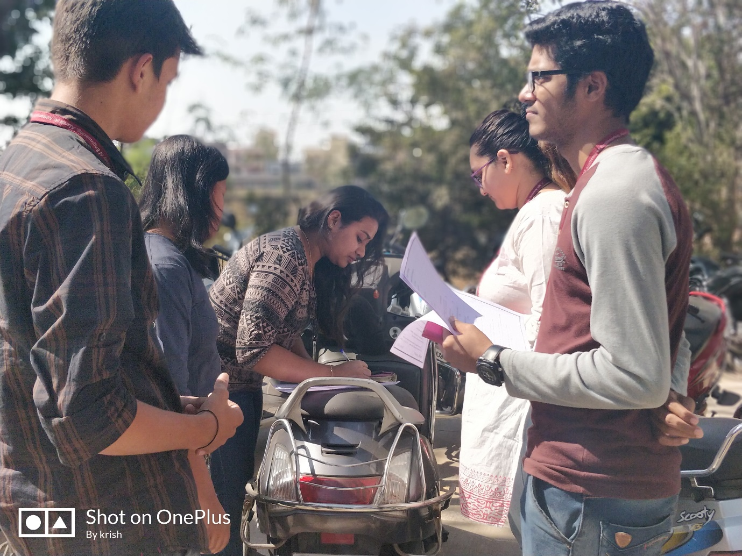
2. 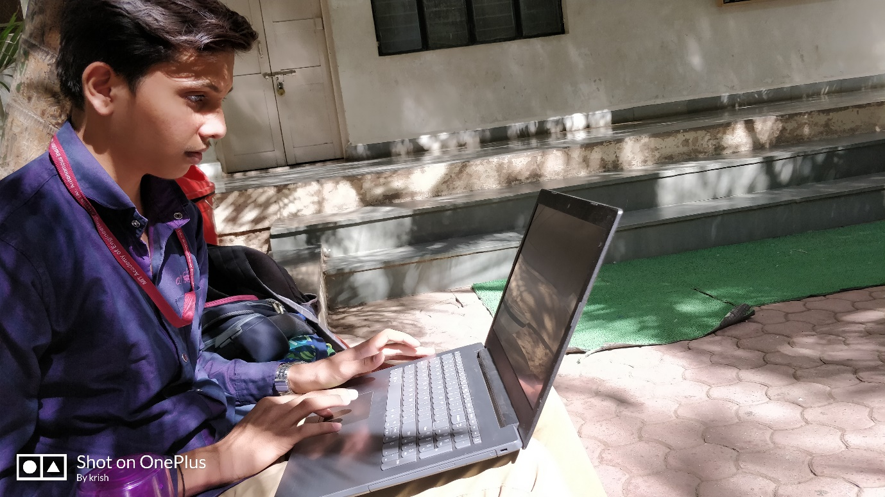
3. 